**Advantages of Requirement Traceability Matrix (RTM):**

1. Gives Overview of ALL the requirements
2. Shows how requirements are linked to Test Cases
3. Makes sure 100% coverage of requirements
4. Easy to prepare
5. No special tool is required

**How to prepare Requirement Traceability Matrix (RTM):**

1. Get all available requirement documents. For eg. Business Requirement Document(BRD), Functional Requirement Document(FSD), Technical Requirement Document(TSD)
2. First list down All the requirements from BRD one by one with requirement ID#
3. Now go to FSD, and list all respective functional requirements for each Business Requirements
4. Open Test Scenario or Test Case document and link available TC IDs to respective Functional Requirements

Lets take an example:

**Project:** Online Flight Booking Application

### **Business Requirement Document (BRD) :**

This document is provided by Client with high level business Requirements. Suppose for Flight Booking Application it shows below 2 requirements

**BR_1  Reservation Module :**

It should allow user to book one or more tickets, one way or round way for future dates

**BR_2  Payment Module:**

User should able to make payment for booked tickets via Credit / Debit Card or through Reward Points

### **Functional Specification Document (FSD) :**

This document is prepared by Technical team which further elaborate business requirements into functional requirements that can be implemented in a software.

Suppose above 2 business requirements in BRD have more detailed functional requirements:

**BR_1  Reservation Module :**

* ***FR_1 : One Way Ticket booking***
  + It should allow user to book one way ticket
* **FR_2 Round Way Ticket**
  + It should allows user to book round way ticket
* **FR_3 Multicity Ticket booking**
  + It should allows user to book one way or round way ticket for multiple cities

**BR_2  Payment Module:**

* **FR_4: By Credit Card**
  + It should allows user to make payment by Credit Cards
* **FR_5 By Debit Card**
  + It should allows user to make payment by Debit Cards
* **FR_6 By Reward Points**
  + It should allows user to make payment by Reward Points

And you have written some test cases or test scenarios for each functional requirement.

[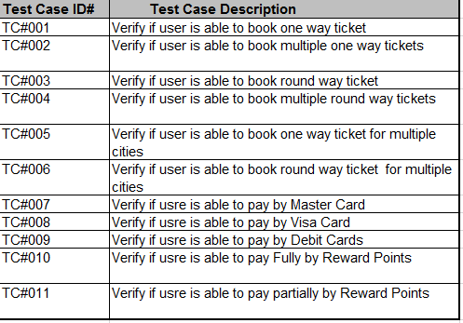](https://www.opencodez.com/wp-content/uploads/2017/02/RTM_TCs.png)

So if we prepare simple Requirements Treaceability Matrix (RTM) for above example it would like as below:

[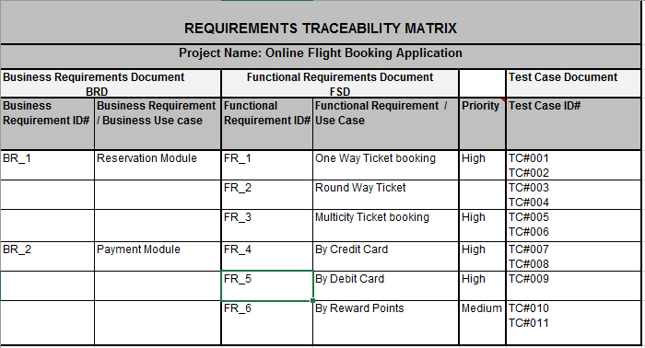](https://www.opencodez.com/wp-content/uploads/2017/02/Requarements-Treaceability-Matrix.png)

You can also add Execution Status and Defects columns in RTM to view overall status of all requirements along with Test Cases.

What is difference between test matrix and traceability matrix?

**Test Matrix**: **Test matrix** is used to capture actual quality, effort, the plan, resources and time required to capture all phases of software **testing**. **Traceability Matrix**: Mapping **between test** cases and customer requirements is known as **Traceability Matrix**

What is the use of traceability matrix?

Definition of 'Requirement **Traceability Matrix**' Definition: Requirements **Traceability Matrix** (RTM) is a document **used** to ensure that the requirements defined for a system are linked at every point during the verification process. It also ensures that they are duly tested with respect to test parameters and protocols.

Why is traceability matrix important?

The main purpose of Requirement **Traceability Matrix** is to see that all test cases are covered so that no functionality should miss while doing Software testing.

Why do we need traceability?

Why Is **Traceability** So Important? ... **Traceability** has three key benefits; it increases supply chain visibility, improves quality control systems and reduces risk. By keeping a record of the entire production and distribution history, suppliers are able to react quickly to any issues.

How useful is the project traceability matrix?

When requirements change midway through a **project**, a **traceability matrix** allows you to identify all of the impacted workflows, test cases, training materials, software code, etc. As a result, you are able to quickly assess the impact of the change and account for it appropriately.

## ****Types of Software Testing Traceability Matrix****

Traceability matrix can be divided into three major types as mentioned below:

##### **1. Forward Traceability**

[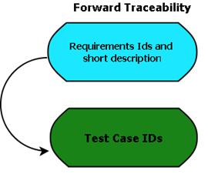](https://www.testbytes.net/wp-content/uploads/2017/11/Forward-Traceability.png)

In this type of traceability matrix, the specific requirements are mapped with test cases.

This implies that the requirements mentioned are used to ascertain the codes that were impacted as well as the type of test cases.

Using this matrix makes it easy to identify and check if the project is moving towards the desired direction and for the precise product.

Thorough testing of each requirement to be met gets easier with this type of matrix. Also, it helps in ensuring that each requirement is applied to the product as well as mapped to test cases.

##### **2. Backward Traceability**

[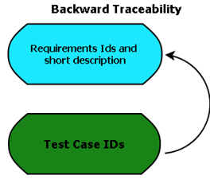](https://www.testbytes.net/wp-content/uploads/2017/11/Backward-Traceability-1.png)

Also known as reverse traceability, this type is used to map test cases with the requirements. In other words, this implies that one should be able to trace the requirement by looking at the test cases.

This type of traceability matrix also helps in ensuring that the existing product continues to remain on the right track.

Along with this, it also helps in confirming that the scope of the present project is not expanding by any activities that are not specified in the requirements such as adding code, test or design elements.

##### **3. Bi-directional Traceability**

[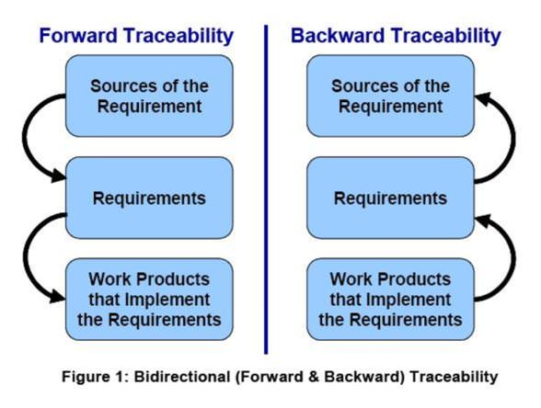](https://www.testbytes.net/wp-content/uploads/2017/11/Bi-directional-Traceability.jpg)

This type of traceability matrix has both forward and backward traceability.

This implies that the test cases are mapped to the requirements as well as the requirements are mapped to test cases.

Using this matrix help in ensuring that all type of requirements are covered by the test cases.

There are a number of ways in which using this traceability matrix is beneficial.

[](https://www.testbytes.net/hire-a-tester/)

Some of these include analyzing the impact of a change in requirements on work product, requirements that were affected due to a certain change or defect in a work product, evaluating the current status of the requirements, identifying missing requirements, identifying gold plating, and others.

#### **Basic Parameters to be included in TM (Traceability Matrix)**

* Requirement ID
* Type and description
* Testcase no:
* Requirement coverage in a number of test cases
* Test design status and the execution of the test status
* Unit test cases
* Integration test cases
* System test cases
* Risks
* UAT (User Acceptance Test) Status
* Defects and current status

#### **How to Create TM (Traceability Matrix)?**

* Make sure that you have all the necessary documents such as business requirement document (BRD) and Functional Requirement Document (FRD)
* List down all the BRD requirement with ID number
* List out all the FSD for each business requirement
* Open test scenario and test case document. Link test case IDs to the respective functional requirement

#### **Template for Traceability Matrix**

[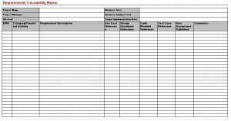](https://www.testbytes.net/wp-content/uploads/2017/11/Untitled.png)

#### **How the Traceability Matrix is useful in testing?**

* Can be used as a planning tool for testing and validation
* Can be used for analyzing existing test suite
* Can be used to asses test coverage
* Can be used for mapping the requirement wit functional validation

#### **Traceability Matrix Workflow**

[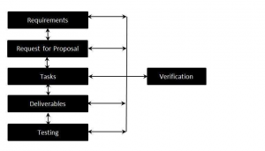](https://www.testbytes.net/wp-content/uploads/2017/11/Untitled-1.png)

#### **Conclusion**

Creating and using traceability matrices is highly recommended as this helps in minimizing the loopholes and errors that might occur during a product’s development.